Source https://www.getyourguide.com/dubai-l173/dubai-highlights-tour-with-burj-khalifa-tickets-t539860/?ranking_uuid=1dc830d1-5e90-4bf7-b1eb-ef2733e5d46c
__________________________________________________________

Dubai Royal Icons Experience: Private City Discovery & Burj Khalifa Summit
__________________________________________________________
★★★★★ 4.8/5 20 reviews

Add to wishlist ♡

__________________________________________________________

1 day | €185 per person

🏕  Image | 🏕  Image | 🏕  Image | 🏕  Image | 🏕  Image | 🏕  Image

__________________________________________________________
About This Tour
Discover Dubai in refined style on a private guided experience that blends modern luxury, cultural heritage, and architectural marvels into one seamless day. Designed for travelers who want more than sightseeing, this curated journey reveals the city’s contrasts — from traditional districts and souks to futuristic skylines — finishing with a breathtaking ascent of the Burj Khalifa for panoramic views of the world’s most dazzling metropolis.
__________________________________________________________
What’s Waiting for You
- Duration: Valid for 1 day
- Group Size: Small group (maximum 6 guests)
- Languages Available: English, Arabic, French
- Guide: Professional live guide included
- Audio Guide: Multilingual audio commentary available
- Transportation: Private luxury vehicle with hotel pickup & drop-off
- Season: Available year-round
__________________________________________________________

Check Dates & Availability

Select participants: (Age 99 and younger) - 1 +

Choose date:
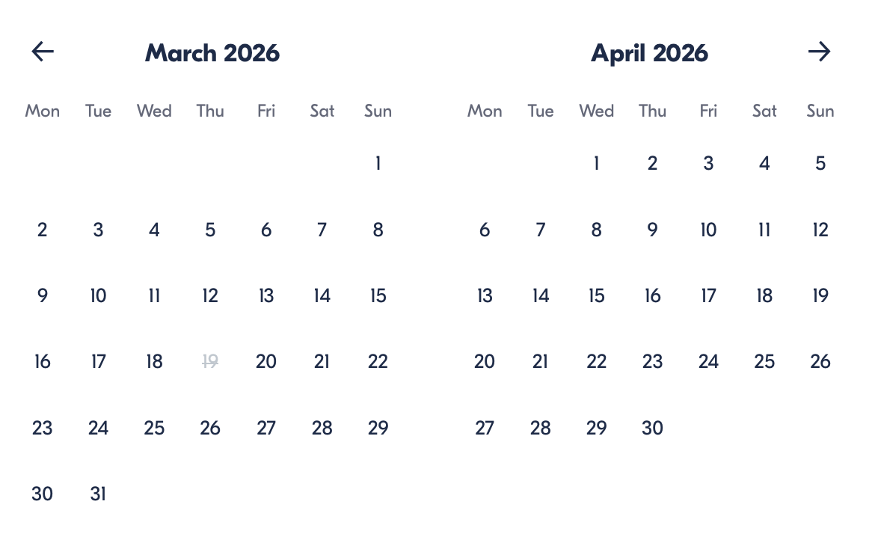

Check Availability

opens:

Participants: 1 March 16, 2026

Dubai Royal Icons Experience: Private City Discovery & Burj Khalifa Summit
- Duration: 1 day
- Offered in: English, Arabic, French
- Start times: 9:00 AM – 3:00 PM or 3:00 PM – 9:30 PM
Cancellation:

- More than 24 hours before start — Full refund
- Less than 24 hours before start — No refund

Price breakdown: 1 Participant x €185

Total: €185

The total price includes all taxes and fees.

Add to cart Book now

__________________________________________________________
Tour Features
- Palm Jumeirah Panorama: See Dubai’s iconic artificial island known for luxury resorts and striking coastal scenery.
- Architectural Drive: Cruise Sheikh Zayed Road past landmarks like the Museum of the Future and Dubai Frame.
- Historic Dubai: Wander through the Al Fahidi district to explore traditional Emirati culture.
- Abra Ride: Cross waterways using a classic wooden water taxi.
- Souk Exploration: Experience the colors and aromas of the Gold and Spice Markets.
- Burj Khalifa Access: Finish your day atop the world’s tallest tower (Levels 124/125).
__________________________________________________________
City Highlights Journey
Your experience begins with a luxury vehicle pickup before heading to Dubai Marina to admire glittering skyscrapers and luxury yachts. Continue toward Palm Jumeirah for photo stops and scenic viewpoints, then drive past world-famous landmarks, including Burj Al Arab and architectural icons along Sheikh Zayed Road.
Next, step into the spiritual calm of the Blue Mosque, where your guide explains Islamic traditions and architectural details. Then explore Al Fahidi, one of Dubai’s oldest neighborhoods, and experience a traditional abra boat ride across the water.
The cultural immersion continues through the lively spice and gold souks, filled with scents, colors, and local atmosphere. Your journey concludes at Dubai Mall, where you’ll witness the musical fountain show before ascending the Burj Khalifa for sweeping skyline views.
__________________________________________________________
Included in Price
- Hotel pickup and drop-off
- Private luxury transportation
- Professional guide
- Drinking water, soft drink, or juice
- Abra boat ride
- City sightseeing tour
- Entry ticket to Burj Khalifa Levels 124/125
__________________________________________________________
Not Included
- Personal expenses
- Meals not specified
__________________________________________________________
Who Should Avoid This Tour
- Travelers with severe mobility limitations (walking required in historic areas and markets)
- Guests uncomfortable with heights (Burj Khalifa observation levels)
__________________________________________________________
Important Trip Info
- Activity duration depends on the selected time slot.
- Small-group format ensures a more personalised experience.
- Security lines at major landmarks may lead to brief wait times.
- Comfortable clothing and walking shoes are recommended.
- Pickup times are confirmed after booking.
__________________________________________________________

Cancellation Policy
For All Participants:

- More than 24 hours before start — Full refund
- 24 hours or less before start — No refund
__________________________________________________________
What Our Clients Are Saying

Overall rating  4.8/5  ★★★★★  Based on 20 reviews | Review summary  Guide 4.5/5  Transportation 4.6/5  Service 4.7/5  Organisation 4.5/5

Filter  - All traveller types  - Couples  - Group of friends  - Families  By star rating  - All star ratings  - 5 stars  - 4 stars  - 3 stars  - 2 stars  - 1 star | Search reviews (e.g., guide)  Sort by:  - Top picks  - Latest reviews  - Best ratings  - Lowest ratings
__________________________________________________________
★★★★★
Daniel W. — Canada
An exceptional way to see Dubai in one day. The private format made it feel exclusive, and the views from the Burj Khalifa were absolutely unforgettable.
★★★★★
Layla N. — UAE
Beautifully organised tour with a fantastic guide. I loved the contrast between historic districts and futuristic architecture.
★★★★★
Ravi K. — Singapore
Everything ran smoothly from pickup to drop-off. The abra ride and souks were highlights, and the skyline views were spectacular.
★★★★★
Elena P. — Italy
Perfect mix of culture and luxury. The Blue Mosque visit was peaceful and informative, and the city drive showed us so much in a short time.
★★★★★
Marcus T. — Australia
Highly recommended for first-time visitors. Seeing Dubai from the top of Burj Khalifa was worth it alone.
See more reviews
__________________________________________________________

Meta tags

Page - Dubai Royal Icons Experience: Private City Discovery & Burj Khalifa Summit

Title: Dubai Royal Icons Experience: Private City Discovery & Burj Khalifa Summit | Travellio Global

Description: Explore Dubai in luxury with a private guided city tour including Burj Khalifa access. Discover iconic landmarks, historic districts, and panoramic skyline views in one unforgettable experience.

H1 - Dubai Royal Icons Experience: Private City Discovery & Burj Khalifa Summit
__________________________________________________________

